**Title: Analyzing HTTP GET Request Using Wireshark**

**Objective:**  
To observe how a browser initiates an HTTP GET request when visiting a webpage and inspect the packet contents.

**Packet Summary:**

* Protocol: HTTP
* Method: GET
* Host: example.com
* Source IP: [Your IP]
* Destination IP: [Server IP]

**Screenshot 1:**  
HTTP GET request in Wireshark packet list

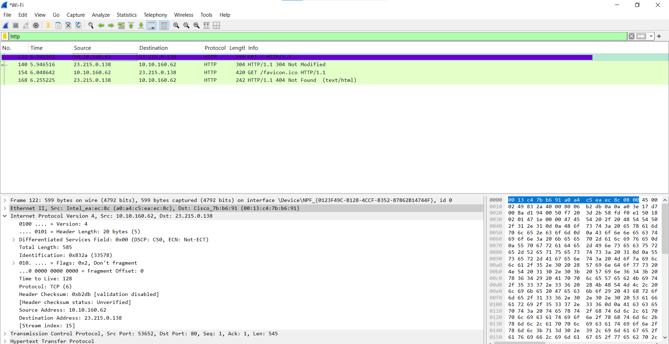

**Screenshot 2:**  
Expanded HTTP section showing:

* Method: GET
* Host: example.com
* User-Agent (browser info)
* Accept (MIME types)

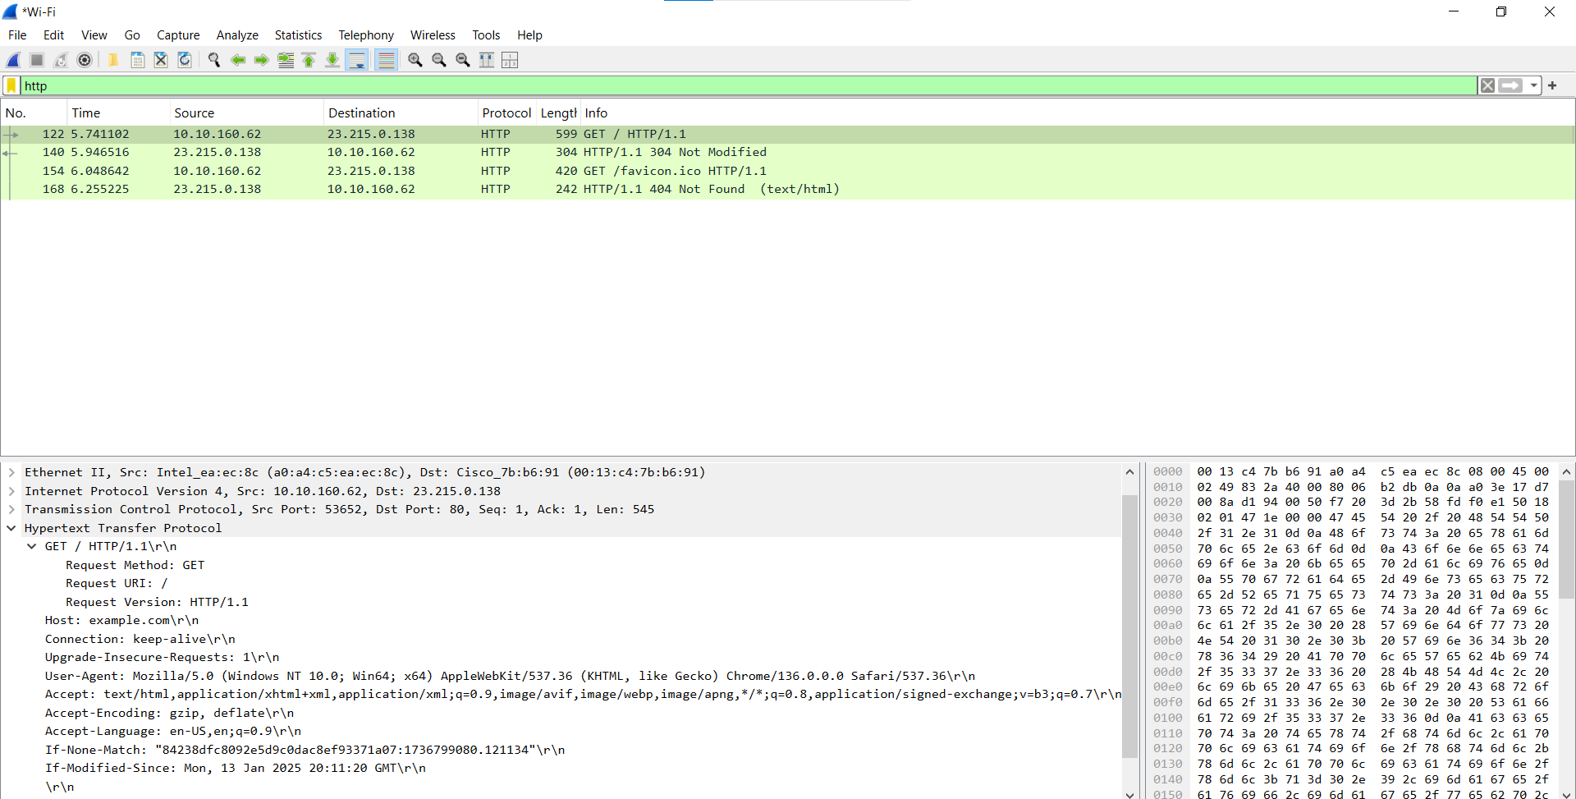

**Conclusion:**  
This packet shows how the client requests resources from a web server using the HTTP GET method. It includes headers like Host and User-Agent, providing insight into the browser and content types request.